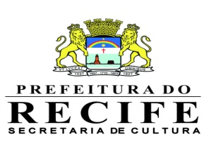
FUNDAÇÃO DE CULTURA CIDADE DO RECIFE
NUCLEO DE CONCURSO E FORMAÇÃO CULTURAL

SÃO JOÃO 2013

15º FESTIVAL DE QUADRILHAS JUNINAS – CATEGORIA INFANTIL

ANEXO I

GRUPO:_______________________________________________________________________

HISTÓRICO:___________________________________________________________________

_______________________________________________________________________________

_______________________________________________________________________________

_______________________________________________________________________________

_______________________________________________________________________________

_______________________________________________________________________________

_______________________________________________________________________________

TEMA:_________________________________________________________________________

ROTEIRO/RESUMO DO TEMA:___________________________________________________

_______________________________________________________________________________

_______________________________________________________________________________

_______________________________________________________________________________

_______________________________________________________________________________

_______________________________________________________________________________

_______________________________________________________________________________

_______________________________________________________________________________

_______________________________________________________________________________

Cidade, de abril de 2013

___________________________
Responsável

